

press release
(English translation)

IEG: collaboration between Ecomondo, KEY and Confindustria Assafrica & Mediterraneo is underway

- Aim: to intensify relations with African and Middle Eastern countries in 2025-2026 through the network of accredited embassies in Italy, the Italian diplomatic system and the main local stakeholders

Rimini (Italy), 3rd February 2025 - Italian Exhibition Group (IEG) and Confindustria Assafrica & Mediterraneo have entered into an important partnership to promote the activities of Ecomondo and KEY The Energy Transition Expo, the two leading exhibitions in the Green and Technology sector, in African and Middle Eastern countries. The objective, part of IEG's event internationalisation policy, is to promote the technologies and frontier solutions that the two shows, and especially Ecomondo, offer in terms of climate change mitigation, correct waste management and water valorisation, with a focus also on bioenergy and the development of renewable energy.

Ecomondo 2025, scheduled to take place at Rimini Expo Centre from 4th to 7th November, will be presented to the African and Middle Eastern diplomatic network in Italy on Wednesday 5th February in Rome at Confindustria’s headquarters.
The meeting will also be attended by representatives from the Ministry of Foreign Affairs and International Cooperation. In the following weeks, the two trade shows will also be promoted to the network of accredited Italian Embassies in these countries and to the main local stakeholders.

Ecomondo 2025 will once again feature the “Africa Green Growth” Forum, now at its 5th edition, which will take an even closer look at cooperation initiatives and future prospects in the circular economy sectors on the African continent with a focus also on the state of the art of the Mattei Plan, recently extended to 5 more countries (Angola, Ghana, Mauritania, Senegal and Tanzania). African markets have been part of Ecomondo’s incoming and promotional activities for several years with 169 operators from this continent in attendance in Rimini at last year’s edition.

PRESS CONTACT - ITALIAN EXHIBITION GROUP
head of media & corporate communication: Elisabetta Vitali; press office manager: Marco Forcellini, Pier Francesco Bellini; international press office coordinator: Silvia Giorgi; press office coordinator: Luca Paganin; press office specialists: Nicoletta Evangelisti, Mirko Malgieri; media@iegexpo.it

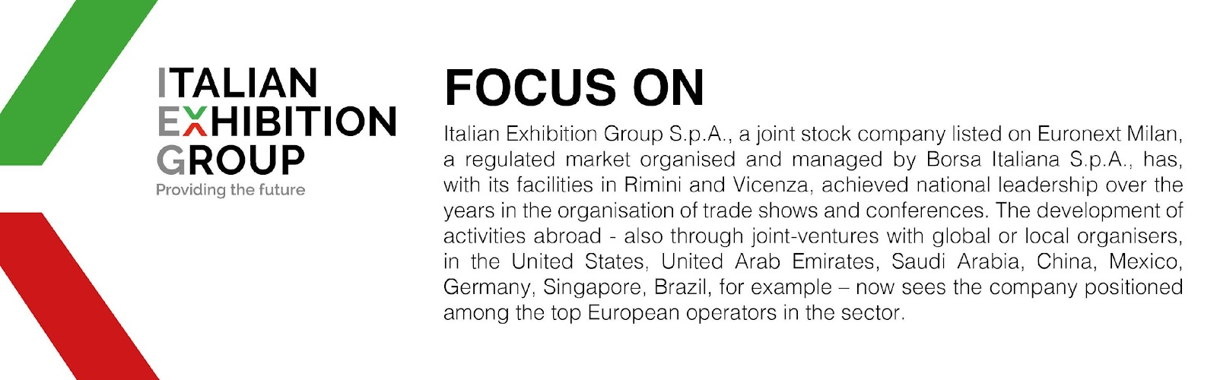

This press release contains forecast elements and estimates that reflect the management’s current opinions (“forward-looking statements”), particularly regarding future management performance, realization of investments, cash flow trends and the evolution of the financial structure. For their very nature, forward-looking statements have a component of risk and uncertainty, as they depend on the occurrence of future events. The effective results may differ (even significantly) from those announced, due to numerous factors, including, only by way of example: food service market and tourist flow trends in Italy, gold and jewellery market trends, green economy market trends; the evolution of raw material prices; general macroeconomic conditions; geopolitical factors and evolutions in the legislative framework. Moreover, the information contained in this release does not claim to be complete, and has not been verified by independent third parties. Forecasts, estimates and objectives contained herein are based on the information available to the Company as at the date of this release.

